**~ Known Issues ~**

Problem: **Mouse scrolling using wheel on Microsoft mouse is very difficult or doesn’t work at all.**

Affects: **Windows desktop and web**

Solution: This is a known issue with Microsoft mouse wheel acceleration. Because it is problematic with some programs, Microsoft provides an easy solution in its IntelliPoint mouse software. Follow these steps to apply the fix:

1. Ensure you have the latest version of IntelliPoint for your mouse hardware downloaded and installed from here: <http://www.microsoft.com/hardware/en-us/downloads#mouse>
2. Open your Control Panel (Start -> Control Panel).
3. Select “Mouse” setup.
4. Click on the “Wheel” tab and select the “Identify programs that don’t scroll correctly…” option (note that your Mouse Properties screen may look a little different):  
   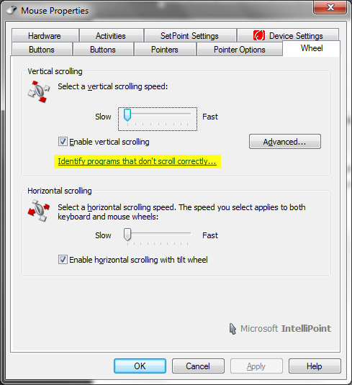
5. Click the “Add…” button.
6. Select “SocialCastr” (or “Receivr”) from the list.
7. Click on “Okay” until all the setup screens are closed.

The change should take effect immediately, even if SocialCastr is already running. If not, try restarting it.